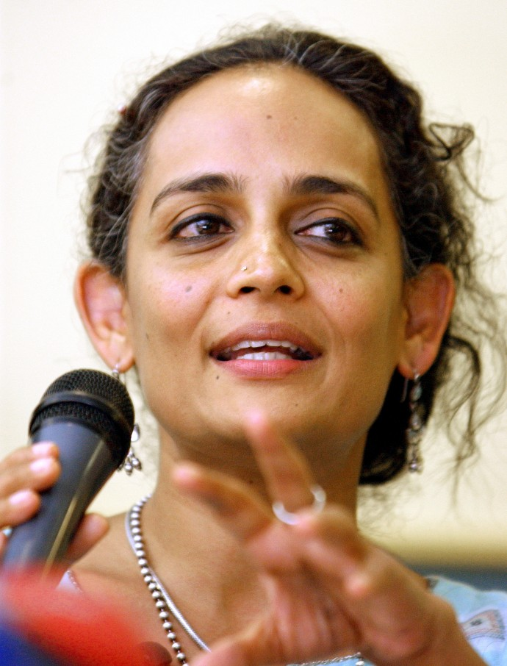
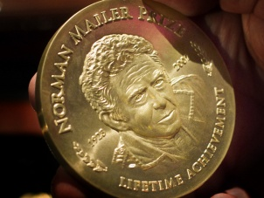
Historical Events (Context)
- 1862: Sino-Indian War
  - Fought between India and China
  - Over disputed territory between both countries
  - Part of Kashmir for the Indians, part of Xinjiang for the Chinese
  - China calls a ceasefire in the end
- 1864: Prime Minister Jawaharlal Nehru dies
- 1966: Nehru’s daughter, Indira Gandi, becomes Prime Minister
- 1971: War with Pakistan
  - Third war that India has fought with Pakistan
  - Fought over the creation of Bangladesh
  - This region used to be East Pakistan
- 1971: Treaty signed with Soviet Union
  - “Friendship Treaty” lasting 20 years
- 1975: Indira declares “State of Emergency”
  - She was found guilty of electoral malpractice
  - Invoked under Article 352 of the Indian constitution
  - In effect, this authorized her to rule by decree
  - She suspended civil liberties and elections
  - Almost 1,000 political opponents were imprisoned
- 1977: Indira’s congress party loses the general elections
  - Janata Political party comes to power
- 1979: The Janata Party is divided
  - Chaudhary Charan Singh is elected the 5th prime Minister of the Republic of India
- 1980: Indira returns to power by leading a splinter group in congress
- 1984: Operation Blue Star
  - Military operation led by Indira Gandi to remove Jarnail Singh Bhindranwale from the “Golden Temple,” the Sikh’s most holy shrine
  - Sikh militant were amassing in the temple, pressing for self-rule
  - The Sikh’s were suspected of planning an uprising
  - There were numerous revolts and anti-Sikh riots
- 1984: Indira Gandi is assassinated by Sikh bodyguards
  - Her son Rajiv takes over
- 1987: India deployed troops to Sri Lanka in order to keep peace during an ethnic conflict
- 1990: Muslim groups begin a violent campaign in Kashmir
- 1991: Rajiv Gandi is assassinated by a suicide bomber
- 1992: Hindu extremists destroy a mosque Ayodhya
  - Triggers widespread violence between Hindus and Muslims in India

